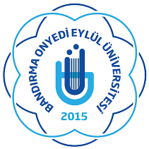 | BANDIRMA ONYEDI EYLUL UNIVERSITY  ERASMUS OFFICE  10200 Bandırma, Balıkesir, TURKEY  Tel.+90 266 717 01 17 / 1041 e-mail: erasmus@bandirma.edu.tr  www.erasmus.bandirma..edu.tr

LLP / ERASMUS PROGRAM
STUDENT MOBILITY
CONFIRMATION OF STUDY PERIOD

(To be filled by the host organization upon the student‘s arrival)

This is to certify that Mr./Ms. _________________________________________________,
Name of the student

from ______________________________________________________________________
Name of the home institution

has been enrolled as an ERASMUS student at __________________________________________________
Name of the host institution

for the period of study from ________________________ to ________________________ .
day / month / year day / month / year

The student arrived on ________________________

______________________ ______________________
Signature University stamp

Name of the signatory : __________________________
Function : ____________________________
Place and date : ____________________________

.........................................................................................................................................................................................................

(To be filled by the host organization upon the student‘s departure)

This is to certify that Mr. /Ms. _________________________________________________,
Name of the student

has finished her/his period of study as an ERASMUS student on ______________________ .
day / month / year

______________________ ______________________
Signature Date University stamp

